**Configure backup for MARS AGENT**

**FOR windows server 2012**

1. **Go to any Vault 🡪 after that go to Backup option🡪select On primes option from dropdown.**
2. **Down load the first point MARS agent setup and copy in the server and then install as below –**

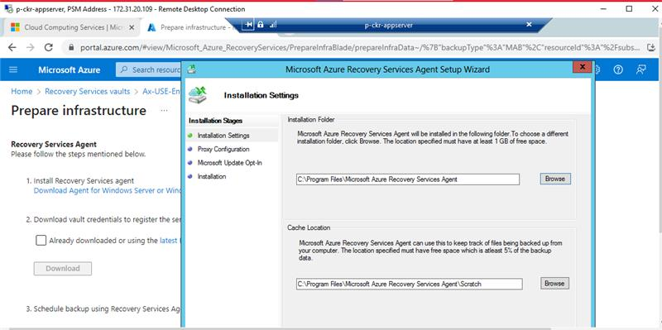

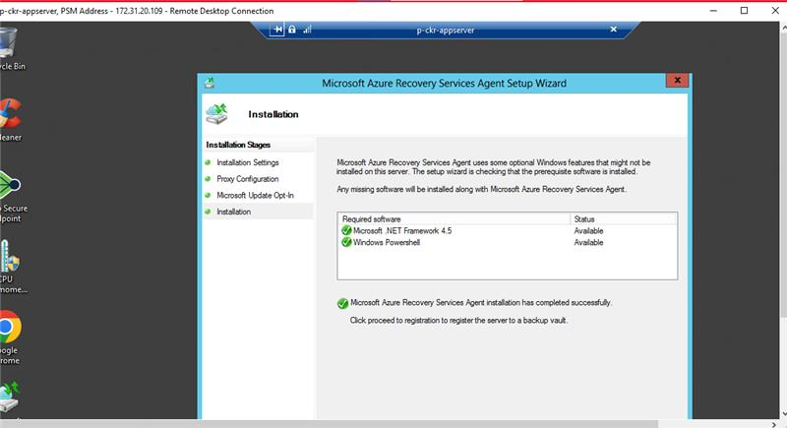

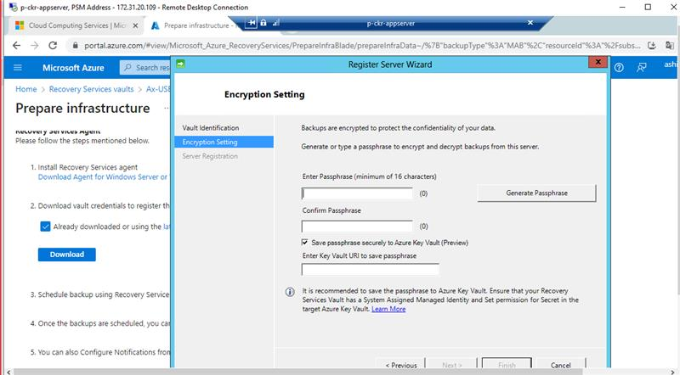

**Generate the passphrase and save this in safe place for future use.**

**After that schedule the backup from schedule backup option.**

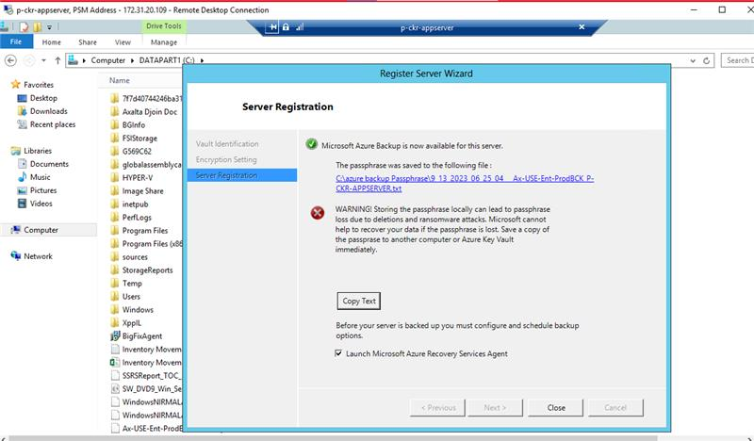

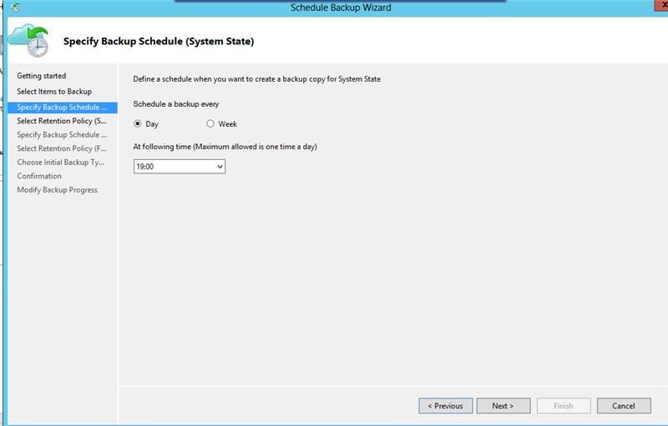

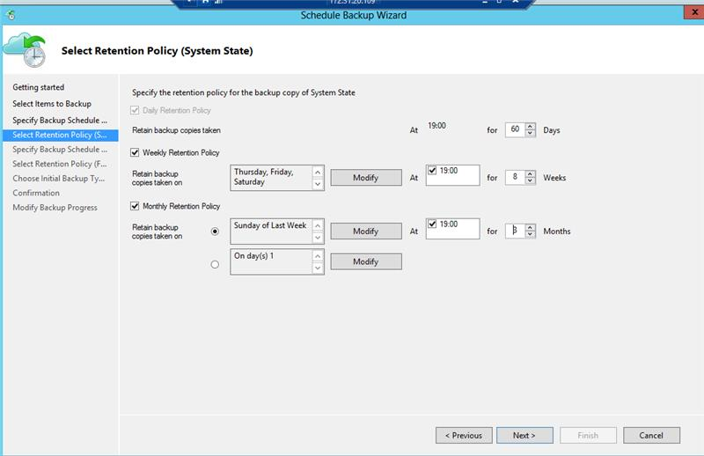

**After confirmation click on finish.**

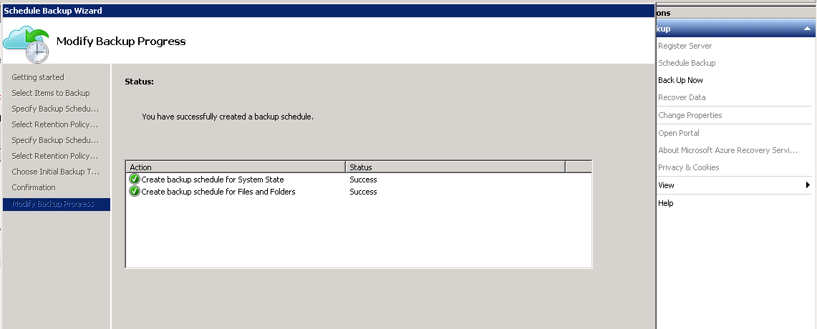

**Passphrase saved in DO NOT DELETE FOLDER IN C DRIVE :**

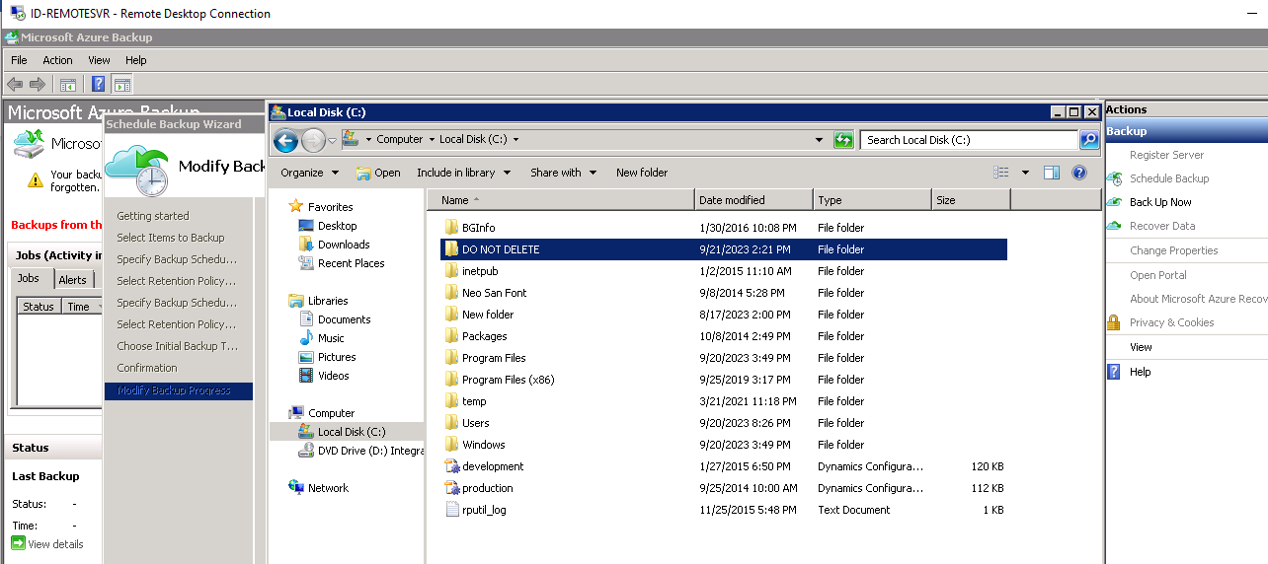

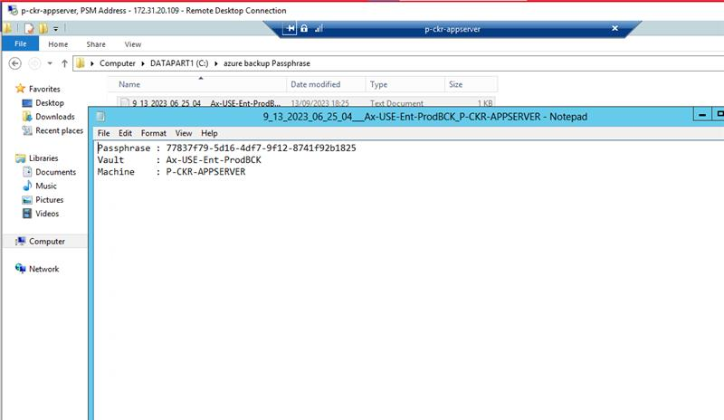

**Finally trigger the backup first time manually.**

**From next day backup will run on scheduled time.**